Bio 20-1: Muscles Unit Test

Targeted Outcomes for this Task:

20-D4.2k - Students will know how muscles contract and that heat is generated in the muscles through contraction.
Approaching | Emerging |  | Developing |  | Confident |  | Extending
I know moving my muscles can make me warm. |  | I know that muscles can only contract and this produces heat.  I know that muscles use actin and myosin to contract and this type of work requires ATP which releases heat. |  | I can explain a muscle cramp referring to how actin and myosin bind and identify the cause of the cramp. |  | I know the relationship between actin, the myosin and the tropomyosin |  | I understand the impact of various substances (i.e.,poisons) and how they impact muscle contraction and function.

20- 4.3s I can analyze and interpret by:
- looking for patterns in my data to help me understand what is happening
- connecting my data to other scenarios and contexts
- coming up with some possible solutions or explanations for what is happening
- organizing and displaying my data in ways that make sense to me
Approaching | Emerging |  | Developing |  | Confident |  | Extending
I can make a logical decision when given choices, by using my background knowledge and observations. |  | I can identify patterns and trends in data and explain relationships among the variables. |  | I can interpret and connect my data to determine possible solutions or explanations for my investigation. |  | I can identify and evaluate potential applications of findings to different scenarios. |  | evaluate designs and prototypes in terms of function, reliability, safety, efficiency, use of materials and impact on the environment

20–4.4s I can communicate my findings by:
- using SI units and Sig Digs
- presenting my findings so it makes sense to others (modes representation)
Approaching | Emerging |  | Developing |  | Confident |  | Extending
I/we don’t give up when things get hard  I/we can participate in a task without or without a group  I/we share my thinking and ideas |  | I/we can understand what needs to be done, I know what the task is asking me/us to do  I/we can communicate findings/results clearly  I/we can use unit vocabulary when responding to tasks |  | I/we can choose my role based on the needs of the assignment and group  I/we can follow the steps of a task  I/we can use of multiple sources of information. |  | I can work to combine input and ideas from everyone in my group and create a clear presentation  I/we can use multiple forms to present our findings (visual, oral, written) |  | I/we can connect our findings to multiple perspectives  I/can ask follow up questions to understand the information

Task Question | Outcomes Targeted
Use these words to fill in the blanks in questions 1a-c below:  contraction  heat  actin  myosin  warm/hot  add some distractors  1 a. I know that when I move my body I feels _____________. | 20-D4.2k (approaching)  20- 4.3s (approaching)  20–4.4s (approaching)
1b. Muscles are made up of _____________ and ______________.  1c. The movement between actin and myosin is done through ________ movement only, and a by-product of this movement produces ATP and ____________. | 20-D4.2k (emerging)  20- 4.3s (approaching)  20–4.4s (approaching)
2. After exercising heavily, athletes sometimes experience muscle cramps. Explain what is happening in the muscle when it is cramping ensuring you reference actin, myosin, and the specific cause of a cramp in your description. | 20-D4.2k (developing)  20–4.4s (approaching/ emerging)
3. Add Scenario question - regarding toxins and how the specifically impact the muscle response. | 20-D4.2k (extending)
4. Use the following information to answer the next two questions.  Normally, skeletal muscle contractions are stimulated and controlled by nerve cells. Calcium ions (Ca²⁺) also play an important role in the way muscles are controlled, as demonstrated by a series of experiments using isolated muscle fibres. These fibres can be manipulated in various ways:  These fibres can be manipulated in various ways:  - They can be stimulated with electrodes to mimic the effect of nerve cells.  - Ca²⁺ in solution can be injected into the fibres.  - A chemical that removes Ca²⁺ already present in the fibres can be injected.  The results from experiments using these procedures are given in the table below.  The Effect of Calcium Ions on Muscle Fibre Contraction  4a. Interpret the results of these experiments.  4b. Based on the evidence above, explain a how the information used above would be beneficial to a medical emergency, or in a training program. | 20-D4.2K (developing)  20- 4.3s (developing)
  Experiment | Procedures |  | Results
  Experiment | Electrode Stimulation | Ca²⁺ injected or removed | Results
  1 | on | neither | contraction
  2 | off | injected | contraction
  3 | on | removed | no contraction
5. Use the following additional information to answer the next two questions.  Additional experiments using injections of radioactive Ca²⁺ show that the ions are stored within the sacs of the sarcoplasmic reticulum in resting muscle tissue. When the tissue is stimulated to contract with electrodes, the radioactive Ca²⁺ ions are found among the actin and myosin filaments as shown below.  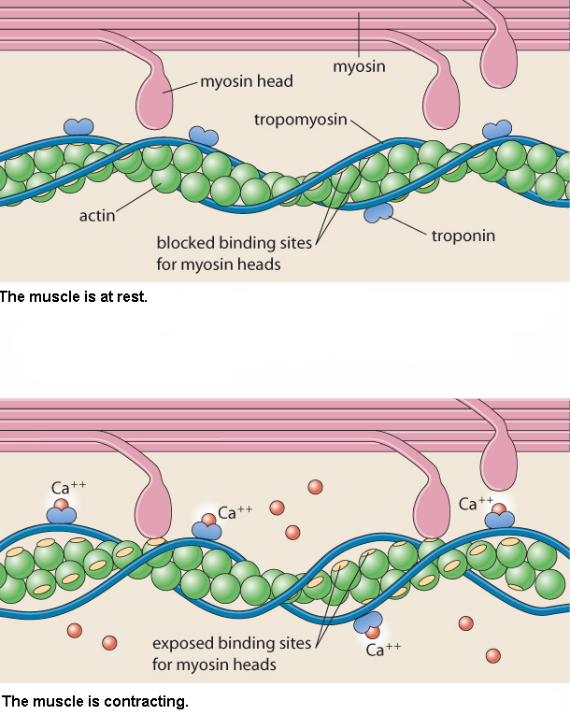  5a. Refer to diagram of the muscle at rest above, and explain what effect a lack of tropomyosin would have in muscle tissue  5b. The diagram of the muscle contracting shows the role of calcium ions in repositioning tropomyosin. Where are these ions stored when the muscle is at rest? What causes them to move among the actin and myosin filaments? | 20-D4.2K (confident)  20–4.4s (approaching/ emerging)
6. Use the following information to answer the next two questions.

The graph shows the oxygen consumption of a subject during a period of rest, exercise, and recovery.
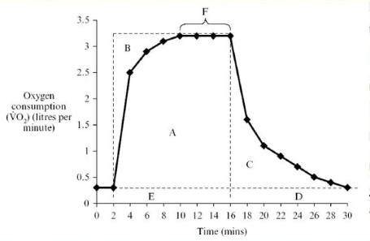
5a. Which letter (A-F) represents the oxygen deficit? | 20-D4.2k (emerging)
b. How long did the exercise last? | 20-D4.2k (emerging)
c. What is occurring during C? | 20- 4.3s (emerging)

